AP* Chemistry
TYPES OF CHEMICAL REACTIONS
& SOLUTION STOICHIOMETRY

Chemists have used reactions to produce the materials Teflon, nylon, Dacron, Kevlar, polystyrene, and PVC among many others!

WATER, THE COMMON SOLVENT
• Properties—high specific heat, high heat of vaporization, high cohesive and adhesive forces
All of these properties contribute to life on this planet!
• H2O—the two O—H bonds are polar covalent [oxygen has a higher electronegativity and thus the electrons are more attracted to the oxygen and spend more time there!]. This creates a partial charge indicated by the dipole symbol, δ

 this unequal charge distribution makes the molecule polar.
Also notice the 105° bond angle, the two unshared electron pairs are “hogs” and require more space than shared pairs thus the usual 109.5° bond angle is squished to about 105°
 There are TWO unshared electron pairs associated with
the oxygen atom that make the partial negative charge -2δ
 hydration—Since opposites attract, the positive ends of
water are greatly attracted to the negative ions in a crystal structure while the converse is also true.
solubility—NaCl is highly soluble while AgCl is classified as insoluble. When the hydration
attractions are greater than the crystal lattice [ion-ion] attractions, the compound is soluble.
Note that the particles are charged IONS.
• They have a full charge rather than the partial charge on the poles of the water molecule.

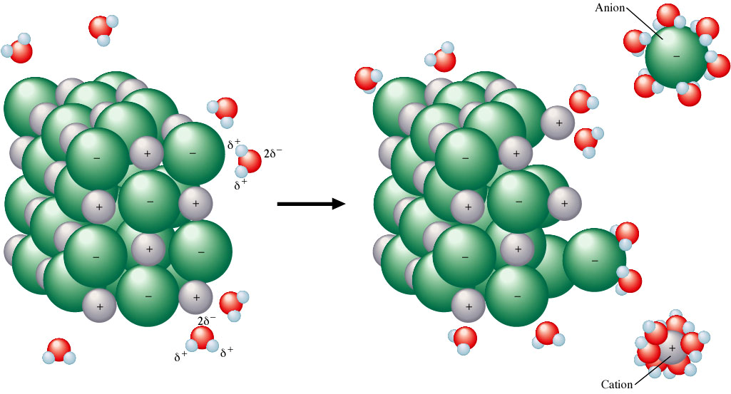

Types of Reactions & Solution Stoichiometry

Water can also dissolve nonionic substances such as alcohols and sugars among others. Alcohols and sugars contain O—H bonds that are polar just as the O—H bond in water. This polarity makes the molecule soluble.

ethanol 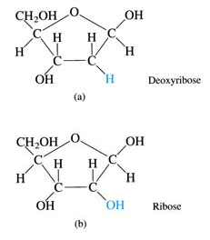

hydration in action!
ethanol attracted to water

Fats do not dissolve in water since they are nonpolar.

“Like dissolves like” is a useful guideline for predicting solubility.

THE NATURE OF AQUEOUS SOLUTIONS: STRONG AND WEAK ELECTROLYTES

Remember a solution is a homogeneous mixture where a solute is dissolved in a solvent. Aqueous
solutions are solutions where the solvent is water.

Properties of Aqueous Solutions
• electrolytes--solutions that conduct an electric current
• strong completely dissociate (consult solubility rules—strong acids, strong bases and soluble salts)
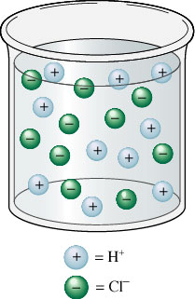

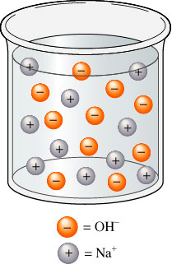

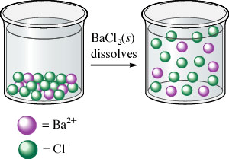
• Barium chloride is an ionic salt that
nearly completely ionizes in water, HCl is a strong acid that completely dissociates into ions in water while NaOH is a strong base that completely dissociates in water. All 3 release charged particles that readily conduct electricity.
• COMMON Strong acids: HCl, HBr, HI, HNO3, HClO₃, H2SO4 [loses first H+ easily and exists mainly as H+ and HSO4- ions in water] AND HClO4
• COMMON Strong bases: Hydroxides of groups 1 and 2.

2
Types of Reactions & Solution Stoichiometry

• weak do not completely dissociate; only about 1% dissociation
(weak acids and bases; ammonia, acetic acid)

nonelectrolytes--solutions where dissolving has occurred but the solute does not make ions and therefore cannot conduct electricity. (Pure water, sugar, alcohols, antifreeze, and starch)
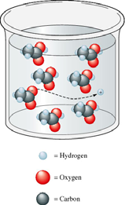

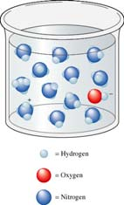

• Arrhenius was the first to identify the conductive properties of solutions in the late 1890’s
he correctly postulated that the extent to which a solution can conduct an electric current
depends directly on the number of ions present.

THE COMPOSITION OF SOLUTIONS

Chemical reactions often take place when two solutions are mixed. To perform stoichiometric calculations in such cases two things must be known: (1) The nature of the reaction which depends on the exact whether or not the substance exists as ions or molecules in solution AND (2) the amount of chemicals present in the solution.

Molarity [M ] =
moles of solute

moles of solution

• Molarity--concentration unit of moles per liter. [NaCl] = 0.75 M means 0.75 moles of salt is contained in 1.00 L of solution. The square brackets indicate whatever is inside is a) in solution and b) its concentration is expressed in molarity.
g
M = FW

Liters of
solution

• Preparing Solutions of KNOWN concentration
• Weigh out the solid as accurately as possible, place in a volumetric flask, add enough distilled water to dissolve the solid THEN add water, filling to the mark on the flask. If you dump solid into 1.00 L of water you are neglecting the space the solid will occupy and your sol’n will NOT be correct.

3
Types of Reactions & Solution Stoichiometry

Exercise 1
Calculate the molarity of a solution prepared by dissolving 11.5 g of solid NaOH in enough water to make 1.50 L of solution.

0.192 M NaOH

Exercise 2
Calculate the molarity of a solution prepared by dissolving 1.56 g or gaseous HC1 in enough water to make 26.8 mL of solution.

1.60 M HC1

• Multiply the ions by their subscript if asked how many are present in a certain M solution of the whole compound.

Exercise 3
Give the concentration of each type of ion in the following solutions

a. 0.50 M Co(NO3)2
b. 1 M Fe(C1O4)3

a. 0.50 M Co2+ and (2 x 0.50) M NO3- or 1.0 M NO3-
b. 1 M Fe3+ ions and 3 M C1O4- ions

ALWAYS REMEMBER AND NEVER EVER FORGET…

. . .Concentration (M) × Volume (in liters) = moles

Number of moles = M × L of solution

4
Types of Reactions & Solution Stoichiometry
Exercise 4
Calculate the number of moles of C1− ions in 1.75 L of 1.0 × 10-3 M ZnC12.

3.5 × 10-3 mol C1-

Exercise 5
Typical blood serum is about 0.14 M NaC1. What volume of blood contains 1.0 mg NaC1?

0.12 mL of blood contains 1.7 × 10-5 mol NaC1 or 1.0 mg NaC1

• Standard solution—is a solution whose concentration is accurately known
ƒ volumetric flask—contains an exact total volume of solution
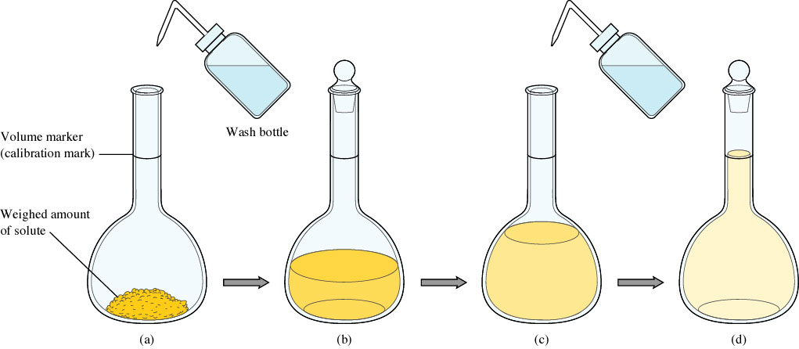

Steps involved in the preparation of a standard solution. a) A weighed amount of a substance (the solute) is put into the volumetric flask, and a small quantity of water is added. (b) The solid is dissolved in the water by gently swirling the flask (with the stopper in place). (c) More water is added, until the level of the solution just reaches the mark etched on the neck of the flask (d).

5
Types of Reactions & Solution Stoichiometry
Exercise 6
To analyze the alcohol content of a certain wine, a chemist needs 1.00 L of an aqueous 0.200 M K2Cr2O7 (potassium dichromate) solution. How much solid K2Cr2O7 must be weighed out to make this solution ? [FYI—this was initially the “stuff” used for breathalyzers!]

58.8 g K2Cr2O7

DILUTION

M1V1

= M 2V2

• Preparing solutions by dilution. Often your sol=n involves diluting a more concentrated soln=. (most common with acids). The more concentrated solution is the stock solution.
• pipet—a device for accurately measuring and transferring a given volume of solution
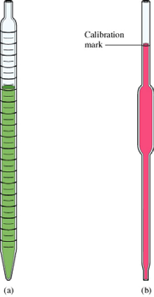

• measuring pipet (a)—used to measure volumes for which a volumetric pipet is not available—has gradations
• volumetric or transfer pipet (b)—gives only one measurement 5mL,
10mL, etc.
Generally, you would measure out the quantity of stock solution you determined from the dilution formula given above, and place it in a volumetric flask that would contain the volume of the diluted solution you needed to prepare. Next, you would fill the volumetric to the mark on the neck with deionized or distilled water until the meniscus reached the mark.

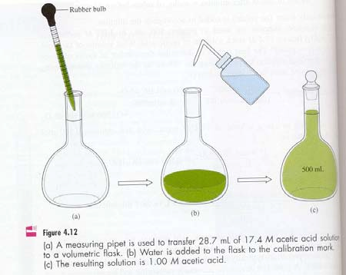

6
Types of Reactions & Solution Stoichiometry

Exercise 7
What volume of 16 M sulfuric acid must be used to prepare 1.5 L of a 0.10 M H2SO4 solution ?

9.4 mL of acid

TYPES OF CHEMICAL REACTIONS

CHEMICAL EQUATIONS
• chemical reaction--transforms elements and compounds into new substances
• balanced chemical equation--shows the relative amounts of reactants and products
• s, l, g, aq--solid, liquid, gas, aqueous solution
• NO ENERGY or TIME is alluded to
• Antoine Lavoisier (1743-1794)--law of conservation of matter: matter can neither be created
nor destroyed; this means “balancing equations”

Not all reactions will fall neatly into just one category.

PRECIPITATION REACTIONS

The formation of a precipitate is a driving force for a chemical reaction. A precipitate is an insoluble solid that is formed when two aqueous solutions are mixed. We often separate the precipitate (ppt) from solution by filtration in what is called a gravimetric analysis.

To identify the precipitate, you MUST know your solubility rules.

7
Types of Reactions & Solution Stoichiometry

SOLUBILITY RULES: Only ones need to memorize!!

1. All salts containing nitrate (NO₃⁻) are soluble
2. All salts containing ammonium (NH₄⁺) are soluble
3. All salts containing Na⁺ are soluble
4. All salts containing K⁺ are soluble

Exercise 8
Using the solubility rules, predict what will happen when the following pairs of solutions are mixed.

a. KNO3(aq) and NaC1(aq)
b. Na2SO4(aq) and Pb(NO3)2(aq)
c. KOH (aq) and Fe(NO3)3(aq)

a. All the ions remain dissolved in solution.
No chemical reaction occurs.
b. The compound NaNO3 is soluble, but PbSO4 is insoluble. Mixed, PbSO4 will precipitate from the solution.
c. K+ and NO3- salts are soluble. Fe(OH)3 is slightly soluble and will precipitate.

DESCRIBING REACTIONS IN SOLUTION
Three ways:

1. COMPLETE balanced equation—gives the overall reaction stoichiometry, but NOT the forms of the reactants & products as they exist in solution
2. complete ionic equation—represents as IONS all reactants & products that are strong electrolytes
3. net ionic equations—includes only those solution components undergoing a change.
Spectator ions are NOT included
• spectator ions--not involved in the reaction process. Started as an ion AND finished as an ion
• THERE IS ALWAYS A CONSERVATION OF MASS, ATOMS, AND CHARGE IN NET IONIC EQUATIONS.

8
Types of Reactions & Solution Stoichiometry

Exercise 9
For each of the following reactions, write the molecular equation, the complete ionic equation, and the net ionic equation.

a. Aqueous potassium chloride is added to aqueous silver nitrate to form a silver chloride precipitate plus aqueous potassium nitrate.

b. Aqueous potassium hydroxide is mixed with aqueous iron(III) nitrate to form a precipitate of iron(III) hydroxide and aqueous potassium nitrate.

Answers:
a. Molecular Equation:
KCI(aq) + AgNO3(aq) → AgC1(s) + KNO3(aq)
Complete Ionic Equation:
K+(aq) + C1-(aq) + NO3-(aq) → AgC1(s) + K+(aq) + NO3-(aq)
Net Ionic Equation:
C1-(aq) + Ag+(aq) → AgC1(s)
b. Molecular Equation:
3KOH(aq) + Fe(NO3)3(aq) → Fe(OH)3(s) + 3KNO3(aq)
Complete Ionic Equation:
3K+(aq) + 3OH-(aq) + Fe3+(aq) + 3NO3-(aq) → Fe(OH)3(s) + 3K+(aq) +3NO3-(aq)
Net Ionic Equation:
3OH-(aq) + Fe3+(aq) → Fe(OH)3(s)

• Chemical analysis of mixtures by PRECIPITATION REACTIONS
form an insoluble salt, filter the salt out and then dry to constant mass.
Use stoichiometry to determine the desired quantity.

Exercise 10
Calculate the mass of solid NaC1 that must be added to 1.50 L of a 0.100 M AgNO3 solution to precipitate all the Ag+ ions in the form of AgC1.

8.77 g NaC1

9
Types of Reactions & Solution Stoichiometry
Exercise 11
When aqueous solutions of Na2SO4 and Pb(NO3)2 are mixed, PbSO4 precipitates. Calculate the mass of PbSO4 formed when 1.25 L of 0.0500 M Pb(NO3)2 and 2.00 L of 0.0250 M Na2SO4 are mixed.

15.2 g PbSO4

ACID-BASE REACTIONS
• acids--any compound that, on reaction with water, produces an ion called the hydronium ion, H3O+
[or H+], and an anion (Arrhenius definition); OR donates H⁺ (Bronsted-Lowry definition)
• base--any compound that provides a hydroxide ion, OH−,and a cation in water (Arrhenius definition)
**ammonia, NH3 is an exception, so Bronsted-Lowry defined it as a proton acceptor.
• neutralization—when moles H⁺ = moles OH⁻ each is neutralized [pH is not necessarily 7.0].
The products formed are a salt [ask yourself if it is soluble] and water

Exercise 12
What volume of a 0.100 M HC1 solution is needed to neutralize 25.0 mL of 0.350 M NaOH ?

8.75 x10-2 L (87.5 mL)

10
Types of Reactions & Solution Stoichiometry
A chance to practice limiting reactant!

Exercise 13
In a certain experiment, 28.0 mL of 0.250 M HNO3 and 53.0 mL of 0.320 M KOH are mixed. Calculate the amount of water formed in the resulting reaction. What is the concentration of H+ or OH− ions in excess after the reaction goes to completion?

0.123 M OH-

TITRATION (MVn = MVn)
o Volumetric analysis—a technique for determining the amount of a certain substance by doing a titration
o titrant—the substance delivered from a buret so that its volume is accurately known
o analyte—the substance being analyzed; its mass or volume must also be accurately known o More terms to know:
- equivalence point--# moles of OH− equals (is equivalent to) # moles of H3O+
[acid-base titration; redox titrations also exist!]
- indicator--undergoes a color change near the equivalence point.
- standardization--a procedure for establishing the exact concentration of a reagent

11
Types of Reactions & Solution Stoichiometry
Exercise 14
A student carries out an experiment to standardize (determine the exact concentration of) a sodium hydroxide solution. To do this the student weighs out a 1.3009-g sample of potassium hydrogen phthalate (KHC8H4O4, often abbreviated KHP). KHP (molar mass 204.22 g/mol) has one acidic hydrogen. The student dissolves the KHP in distilled water, adds phenolphthalein as an indicator, and titrates the resulting solution with the sodium hydroxide solution to the phenolphthalein endpoint.
The difference between the final and initial buret readings indicates that 41.20 mL of the sodium hydroxide solution is required to react exactly with the 1.3009 g KHP. Calculate the concentration of the sodium hydroxide solution.

0.1546 M

Exercise 15
An environmental chemist analyzed the effluent (the released waste material) from an industrial process known to produce the compounds carbon tetrachloride (CC14) and benzoic acid (HC7H5O2), a weak acid that has one acidic hydrogen atom per molecule. A sample of this effluent weighing 0.3518 g was shaken with water, and the resulting aqueous solution required 10.59 mL of 0.1546 M NaOH
for neutralization. Calculate the mass percent of HC7H5O2 in the original sample.

56.82%

12
Types of Reactions & Solution Stoichiometry
OXIDATION-REDUCTION (“REDOX”) REACTIONS involve electron transfer

Terms to Know:

OIL RIG – oxidation is loss, reduction is gain (of electrons) Oxidation – the loss of electrons, increase in charge Reduction – the gain of electrons, reduction of charge Oxidation number – the assigned charge on an atom

Rules for Assigning Oxidation States
1. The oxidation state of an atom in an element is ZERO including allotropes [i.e. N2, P4, S8].
2. The oxidation state of a monatomic ion is the same as its charge.
3. In its compounds, fluorine is always assigned an oxidation state of -1.
4. Oxygen is usually assigned an oxidation state of -2 in its covalent compounds, such as CO, CO2, SO2, and SO3. Exceptions to this rule include peroxides (compounds containing the O22- group), where each oxygen is assigned an oxidation state of -1, as in hydrogen peroxide (H2O2), and OF2 in which oxygen is assigned a +2 oxidation state.
5. In its covalent compounds with nonmetals, hydrogen is assigned an oxidation state
of +1. Metal hydrides are an exception; H is at the end of the chemical formula since it has an oxidation state of 1-.
6. The sum of the oxidation states must be zero for an electrically neutral compound.
For a polyatomic ion, the sum of the oxidation states must equal the charge of the ion.

Exercise 16
Assign oxidation states to all atoms in the following. a. CO2
b. SF6
c. NO3−

a. oxygen is -2 & carbon is 4 b. fluorine is -6 & sulfer is +6
c. oxygen is -6 & nitrogen is +5

While very rare, there can be non-integer oxidation states like in Fe3O4. There’s a -8 for the 4 oxygens divided across 3 iron ions, therefore Fe’s charge is Fe8/3+

13
Types of Reactions & Solution Stoichiometry
Exercise 17
When powdered aluminum metal is mixed with pulverized iodine crystals and a drop of water is added to help the reaction get started, the resulting reaction produces a great deal of energy. The mixture bursts into flames, and a purple smoke of I2 vapor is produced from the excess iodine. The equation for the reaction is

2A1(s) + 3I2(s) → 2AlI3(s)

For this reaction, identify the atoms that are oxidized and reduced.

Aluminum is oxidized; Iodine is reduced

Exercise 18
Metallurgy, the process of producing a metal from its ore, always involves oxidation-reduction reactions. In the metallurgy of galena (PbS), the principal lead-containing ore, the first step is the conversion of lead sulfide to its oxide (a process called roasting):

2PbS(s) + 3O2(g) → 2PbO(s) + 2SO2(g)

The oxide is then treated with carbon monoxide to produce the free metal: PbO(s) + CO(g) → Pb(s) + CO2(g)
For each reaction, identify the atoms that are oxidized and reduced.

First Reaction:
sulfur is oxidized; oxygen is reduced

Second Reaction:
carbon is oxidized; lead is reduced

14
Types of Reactions & Solution Stoichiometry

