Physics Chapter 6.1-6.3 Name _________________
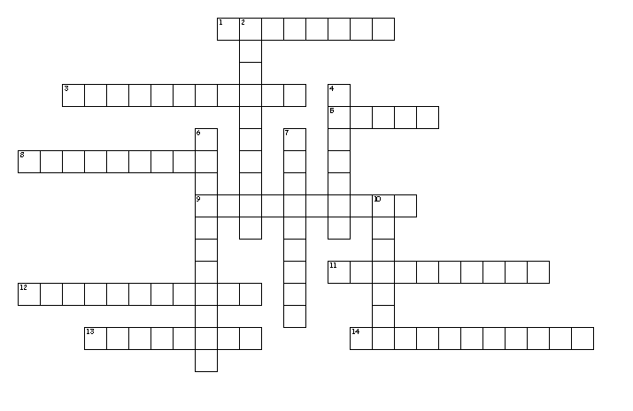
Across
1. This part of a projectile's speed is always changing because of gravity.
3. Law of Universal _____ describes the relationship between mass, distance and force.
5. Distance a projectile travels.
8. At what angle should you kick a soccer ball if you want to have the greatest range? (spell the number)
9. The path of a projectile.
11. An object that moves through the air affected only by gravity.
12. Two kids are sitting on a merry-go-round. The kid on the outer horse will have a greater ______ but the same angular speed.
13. If the distance between two planets were to increase the gravity would ____.
14. Fake force to explain your own inertia trying to carry you out of a circle.
Down
2. Shape of planet's orbits around the sun.
4. Keeps the moon in orbit around the earth.
6. An inward ______ force is needed to keep an object moving in a circle.
7. Object that orbits the earth.
10. When an object moves around an external axis.

A go cart is driving around a circular track with a radius of 25m. If the time around the track is 95 seconds what is the go cart’s speed?

If the cart and rider have a mass of 1335 kg, what centripetal force is required to keep the go-cart in the circle?

