**C:\Documents and Settings\toukonen\Local Settings\Temporary Internet Files\Content.IE5\CKIK37JI\MCSY01853_0000[1].wmfHonors Final Exam Review**

**Worksheet 7**

1. Calculate the molar mass of a gas for which 75 grams occupies 500 ml at STP (Ch. 11). **(3409 g/mol)**
2. A sample of nitrogen gas is saturated with water vapor at 27°C. The total pressure of the mixture is 680 mmHg, and the vapor pressure of water is 26.7 torr at 27°C. What is the partial pressure of the nitrogen gas (Ch. 11)?  
   **(653.30 mmHg)**
3. Determine the energy absorbed when 500 grams of water is melted (Ch. 12). **(167,222 J)**
4. Answer the following questions regarding the phase diagram below (Ch. 12):
   1. What state of matter is present at 110 kPa and 50 ⁰C?
   2. What is the significance of the “normal” melting point or “normal” boiling point?
   3. What is unique about the triple point?

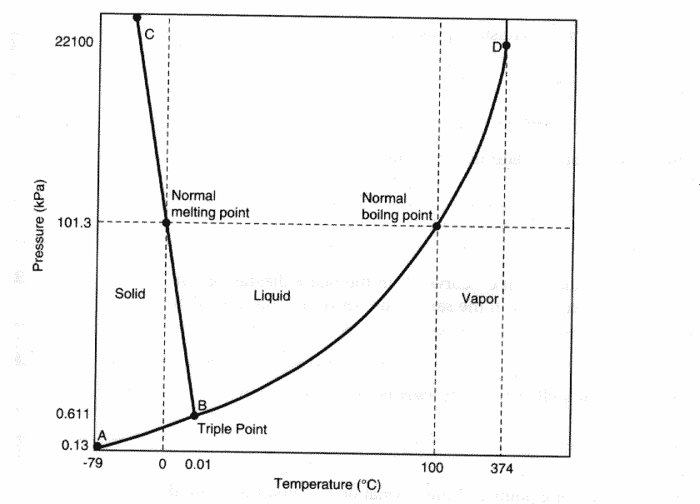

1. Determine the mass of hydrogen gas present if 300 ml of gas is present at a pressure of 2.1 atm and 25⁰C (Ch.11). **(0.05 g)**
2. Draw Lewis structures for the following molecules, then indicate electron arrangement, shape and polarity (Ch. 10): H2O2, H2S, I3 1-
3. Calculate the mass of carbon dioxide produced when 45 L of oxygen at STP is consumed in the burning of octane (C8H18) (Ch. 11). **(56 g)**
4. Briefly describe the significance of quantum mechanics (Ch. 9).
5. A calorimeter has a heat capacity of 1900 J/⁰C. If 500 grams of methane, with a heat of combustion of 4.94 kJ/mole is burned in this calorimeter, how much will the temperature rise? The molar mass for methane is 16 grams (Ch. 12). **(81.25 ⁰C)**
6. Rank the following elements from lowest electronegativity to highest electronegativity (Ch. 9): Te, Mo, Sr, Xe and I.