AP*Chemistry
The Chemistry of Acids and Bases

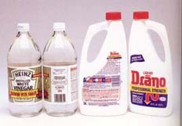"ACID"--Latin word acidus, meaning sour. (lemon)
"ALKALI"--Arabic word for the ashes that come from burning certain plants;
water solutions feel slippery and taste bitter. (soap)

Acids and bases are extremely important in many everyday applications: our own bloodstream, our environment, cleaning materials, and industry. (Sulfuric acid is an economic indicator!)

ACID-BASE THEORIES
ARRHENIUS DEFINITION
acid--donates a hydrogen ion (H+) in water
base--donates a hydroxide ion in water (OH−)
This theory was limited to substances with those "parts"; ammonia is a MAJOR exception!

BRONSTED-LOWRY DEFINITION
acid--donates a proton in water
base--accepts a proton in water
This theory is better; it explains ammonia as a base! This is the main theory that we will use for our acid/base discussion.

THE BRONSTED-LOWRY CONCEPT OF ACIDS AND BASES
Using this theory, you should be able to write weak acid/base dissociation equations and identify acid, base, conjugate acid and conjugate base.
conjugate acid-base pair--A pair of compounds that differ by the presence of one H+ unit. This idea is critical when it comes to understanding buffer systems.

HNO3 + H2O → H3O+ + NO3− neutral compound as an acid acid base CA CB

NH4+ + H2O → H3O+ + NH3 cation as an acid acid base CA CB

H2PO4− + H2O → H3O+ + HPO42− anion as an acid acid base CA CB

In each of the acid examples---notice the formation of H3O+ -- this species is named the hydronium ion. It lets you know that the solution is acidic!

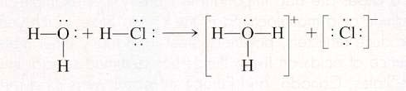

NH3 + H2O → NH4+ + OH− base acid CA CB

CO32− + H2O → HCO3− + OH− base acid CA CB

PO43− + H2O → HPO42− + OH− base acid CA CB

Notice the formation of OH− in each of the alkaline examples. This species is named the hydroxide ion. It lets you know that the resulting solution is basic!
Exercise 1
a) In the following reaction, identify the acid on the left and its CB on the right. Similarly identify the
base on the left and its CA on the right.

HBr + NH3 → NH4+ + Br−

b) What is the conjugate base of H2S?

c) What is the conjugate acid of NO3-?

ACIDS DONATE ONLY ONE PROTON AT A TIME

monoprotic--acids donating one H+ (ex. HC2H3O2)
diprotic--acids donating two H+'s (ex. H2C2O4)
polyprotic--acids donating many H+'s (ex. H3PO4)

polyprotic bases--accept more than one H+; anions with −2 and −3 charges (ex. PO43− ; HPO42−)

Amphoteric --molecules or ions that can behave as EITHER acids or bases; water, anions of weak acids (look at the examples above—sometimes water was an acid, sometimes it acted as a base)

Exercise 2 Acid Dissociation (Ionization) Reactions

Write the simple dissociation (ionization) reaction (omitting water) for each of the following acids.

a. Hydrochloric acid (HCl)

b. Acetic acid (HC2H3O2)

c. The ammonium ion (NH4+)

d. The anilinium ion (C6H5NH3+)

e. The hydrated aluminum(III) ion [Al(H2O)6]3+
A: HCl(aq) → H+(aq) + Cl-(aq)
B: HC2H3O2(aq) → H+(aq) + C2H3O2-(aq)
C: NH4+(aq) → H+(aq) + NH3(aq)
D: C6H5NH3+(aq) → H+(aq) + C6H5NH2(aq)
E: Al(H2O)63+(aq) → H+(aq) + [Al(H2O)5OH]2+(aq)
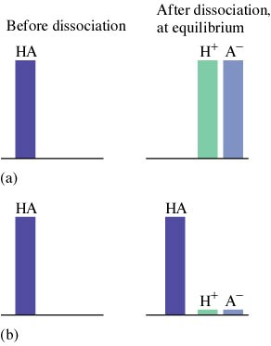
RELATIVE STRENGTHS OF ACIDS AND BASES
Strength is determined by the position of the "dissociation" equilibrium.
Strong acids/strong bases
1. dissociates completely in water
2. have very large dissociation or K values

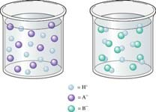Strong Weak

Weak acids/weak bases
1. dissociate only to a slight extent in water
2. dissociation constant is very small

Do Not confuse concentration with strength!

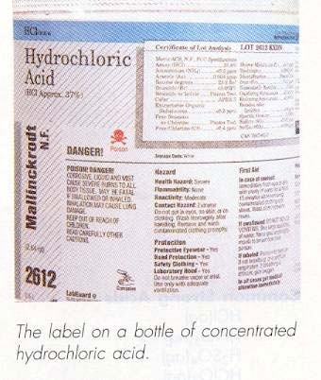 STRONG ACIDS: Memorize these SEVEN
Hydrohalic acids: HCl, HBr, HI—note HF is missing
Nitric: HNO3
Sulfuric: H2SO4
Chloric HClO₃
Perchloric: HClO4

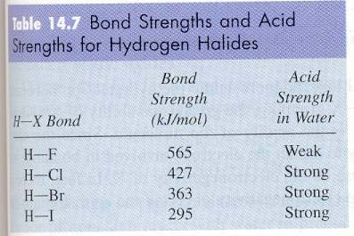
The more oxygen present in the polyatomic ion of an oxyacid, the stronger its acid WITHIN that group. That’s a trend, but not an explanation. So, why? First, notice that the H of the acid is bound to an oxygen and NOT any other nonmetal present. Oxygen is very electronegative and attracts the electrons of the O−H bonds toward itself. If you add more oxygens, then this effect is magnified and there is increasing electron density in the region of the molecule that is opposite the H. The added electron density weakens the bond, thus less energy is required to break the bond and the acid dissociates more readily which we describe as “strong”.

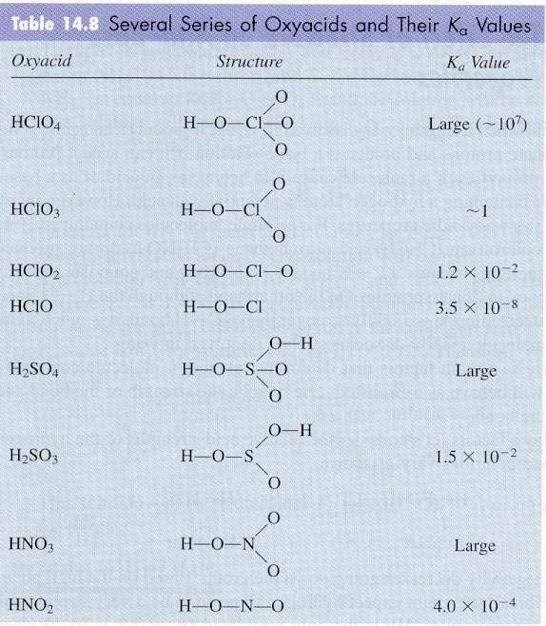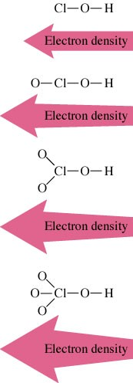

STRONG BASES
Hydroxides OR oxides of IA and IIA metals (except Mg and Be)
o Solubility plays a role (those that are very soluble are strong!)

THE STRONGER THE ACID THE WEAKER ITS CB, the converse is also true.

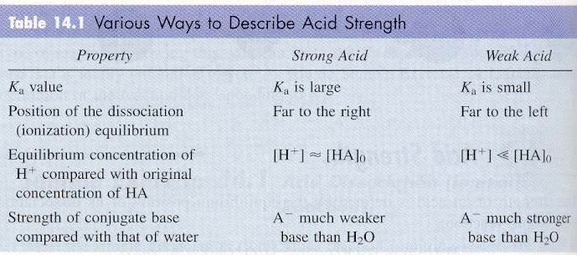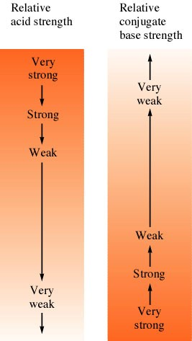
WEAK ACIDS AND BASES:

The vast majority of acid/bases are weak. Remember, this means they do not ionize much.

That means a equilibrium is established and it lies far to the left (reactant favored).
The equilibrium expression for acids is known as the Ka (the acid dissociation constant). It is set up the same way as any other equilibrium expression. Many common weak acids are oxyacids, like phosphoric acid and nitrous acid. Other common weak acids are organic acids—
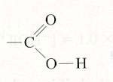those that contain a carboxyl group, the COOH group, like acetic acid and benzoic acid.

For weak acid reactions: HA + H2O ↔ H3O+ + A−

Ka = [H3O+][A−] < < 1 [HA]

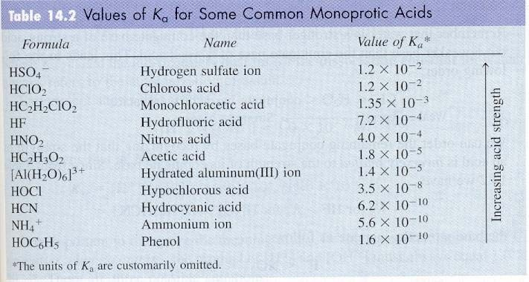

Write the Ka expression for acetic acid. (Note: Water is a pure liquid and is thus, left out of the equilibrium expression.)

Weak bases (bases without OH−) react with water to produce a hydroxide ion. Common examples of weak bases are ammonia (NH3), methylamine (CH3NH2), and ethylamine (C2H5NH2). The lone pair on N forms a bond with a H+. Most weak bases involve N.

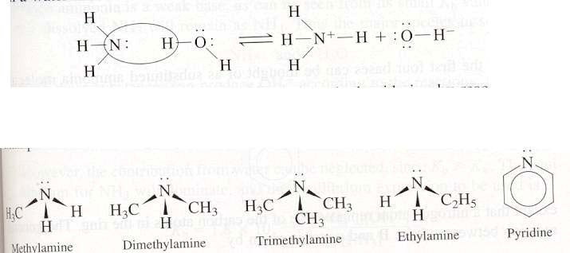

The equilibrium expression for bases is known as the Kb.

for weak base reactions: B + H2O ↔ HB+ + OH−

Kb = [HB+][OH−] << 1 [B]

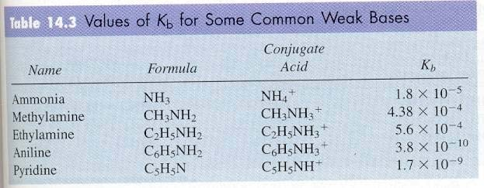

♦ Write the Kb expression for ammonia.

♦ Notice that Ka and Kb expressions look very similar. The difference is that a base produces the hydroxide ion in solution, while the acid produces the hydronium ion in solution.
♦ Another note on this point: H+ and H3O+ are both equivalent terms here.
Often water is left completely out of the equation since it does not appear in the
equilibrium. This has become an accepted practice. (* However, water is very important in causing the acid to dissociate.)

Exercise 3 Relative Base Strength

Using table 14.2, arrange the following species according to their strength as bases: H2O, F−, Cl−, NO2−, and CN−.

Cl- < H2O < F- < NO2- < CN-
WATER, THE HYDRONIUM ION, AUTO-IONIZATION, AND THE pH SCALE

Fredrich Kohlrausch, around 1900, found that no matter how pure water is, it still conducts a minute amount of electric current. This proves that water self-ionizes.

• Since the water molecule is amphoteric, it may dissociate with itself to a slight extent.
• Only about 2 in a billion water molecules are ionized at any instant!

H2O(l) + H2O(l) ↔ H3O+(aq) + OH−(aq)

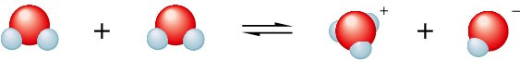

• The equilibrium expression used here is referred to as the autoionization constant for water, Kw
• In pure water or dilute aqueous solutions, the concentration of water can be considered to be a constant (55.6 M), so we include that with the equilibrium constant and write the expression as:

Kw = [H3O+][OH−] = 1.008 × 10−14 @ 25°C = Ka × Kb

♦ Knowing this value allows us to calculate the OH− and H+ concentration for various situations.
♦ [OH−] = [H+] solution is neutral (in pure water, each of these is 1.0 × 10−7)
♦ [OH−] > [H+] solution is basic
♦ [OH−] < [H+] solution is acidic

Exercise 4 Autoionization of Water

At 60°C, the value of Kw is 1 × 10−13.

a. Using Le Chatelier’s principle, predict whether the reaction below is exothermic or endothermic.

2H2O(l) ↔ H3O+(aq) + OH−(aq)

b. Calculate [H+] and [OH−] in a neutral solution at 60°C.

A: endothermic
B: [H+] = [OH−] = 3 × 10-7 M

The pH Scale
Used to designate the [H+] in most aqueous solutions where [H+] is small. pH = −log [H+]
pOH = − log [OH−]
pH + pOH = 14

If pH is between zero and 6.999, the solution is acidic, if pH is 7.000, the solution is neutral and if the pH is above 7.000, the solution is basic.

Reporting the correct number of sig. figs on a pH is problematic since it is a logarithmic scale. The rule is to report as many decimal places on a pH as there are in the least accurate measurement you are given.

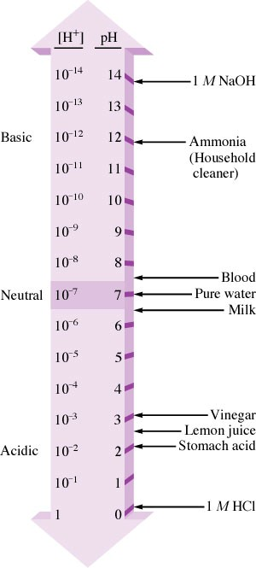 Example: The problem states a 1.15 M solution. That is your cue to report a pH with 3 decimal places. If the problem had stated a 1.2 M solution, then you would report your calculated pH to 2 decimal places.

Exercise 5 Calculating [H+] and [OH−]

Calculate either the [H+] or [OH−] from the information given for each of the following solutions at 25°C, and state whether the solution is neutral, acidic, or basic.

a. 1.0 × 10−5 M OH−

b. 1.0 × 10−7 M OH−

c. 10.0 M H+

A: [H+] = 1.0 × 10-9 M, basic B: [H+] = 1.0 × 10-7 M, neutral C: [OH−] = 1.0 × 10-15 M, acidic
Exercise 6 Calculating pH and pOH

Calculate pH and pOH for each of the following solutions at 25°C.

a. 1.0 × 10−3 M OH−

b. 1.0 M H+

A: pH = 11.00 pOH = 3.00
B: pH = 0.00 pOH = 14.00

Exercise 7 Calculating pH
The pH of a sample of human blood was measured to be 7.41 at 25°C. Calculate pOH, [H+], and [OH−] for the sample.

pOH = 6.59 [H+] = 3.9 × 10-8 M [OH−] = 2.6 × 10-7 M

Exercise 8 pH of Strong Acids

a. Calculate the pH of 0.10 M HNO3.

b. Calculate the pH of 1.0 × 10−10 M HCl.

A: pH = 1.00
B: pH = 7.00
Exercise 9 The pH of Strong Bases

Calculate the pH of a 5.0 × 10−2 M NaOH solution.

pH = 12.70

Calculating pH of Weak Acid Solutions
Calculating pH of weak acids involves setting up an equilibrium. Always start by writing the balanced equation, setting up the acid equilibrium expression (Ka), defining initial concentrations, changes, and final concentrations in terms of x, substituting values and variables into the Ka expression and solving for x. Use the ICE TABLE method you learned in general equilibrium!

Example
Calculate the pH of a 1.00 × 10−4 M solution of acetic acid. The Ka of acetic acid is 1.8 × 10−5.

H+ + C2H3O2−
0 0
2
Change −x +x +x
Reaction | HC2H3O2 | R
Initial | 1.00 × 10−4

Equilibrium (1.00 × 10−4 ) − x x x

+ −
⎡⎣H ⎤⎦ ⎡⎣=C H O ⎤⎦
K = 2 3 2 = 1.8 ×10−5 = x
a HC H O 1×10−4 − x
2 3 2

See that –x term in the denominator? That is your invitation to cross multiply and distribute the Ka value across the term so that you get x2 = 1.8 × 10−9 – 1.8 × 10−5x ; collect like terms and use either the solver on your graphing calculator or a quadratic formula solving program you’ve loaded on your calculator (all of this to avoid arithmetic mistakes!) to solve for x. You should determine that x = [H+] = 3.44 × 10−4 and that the pH = − log (3.44 × 10−4) = 3.46 (2 SF).

Often, the –x term in a Ka expression can be neglected. That simplifies the math tremendously since you are now spared the tedium of having to use the quadratic formula.

How do you know when to neglect x? Easy. Look at the original concentration and compare it to 100 Ka (or 100 Kb). IF the initial concentration is large by comparison, you can neglect subtracting the x term. We could not neglect x in the example we just worked since 100 Ka for acetic acid would equal 1.8 × 10−3 or 0.0018 which is too close to our initial acid concentration of 0.0001.
Suppose our initial concentration had been 0.10 M for the acetic acid in the example problem we just worked. For acetic acid, 100Ka = 1.8 × 10−3 or 0.0018. That’s essentially subtracting zero from 0.10 M. Aside from that if you did subtract it, you’d still follow the “least decimal place” subtraction sig. fig. rule and report 0.10 M as your answer to the subtraction.

Example
Calculate the pH of a 10.10 M solution of acetic acid. The Ka of acetic acid is 1.8 × 10−5.

Reaction HC2H3O2 ↔ H+ |  |  | + | C2H3O2−
Initial Change Equilibrium | 0.10  −x  0.10 − x | 0  +x x |  | 0  +x x

+ −
⎡⎣H ⎤⎦ ⎡⎣=C H O ⎤⎦
K = 2 3 2 = 1.8 ×10−5 =
a
HC2 H3O2
x2
0.10 − x

By cross multiplying and NOT neglecting x, you get x2 = 1.8 × 10−6 – 1.8 × 10−5x ; collect like terms and use either the solver on your graphing calculator or a quadratic formula solving program you’ve loaded on your calculator (all of this to avoid arithmetic mistakes!) to solve for x. You should determine that
x = [H+] = 0.0013327 (way too many sig. figs!)
and that the pH = − log (0.0013327) = 2.88 (2 SF) Had we “neglected x”, the math simplifies to
+ −
⎡⎣H ⎤⎦ ⎡⎣=C H O ⎤⎦
K = 2 3 2 = 1.8 ×10−5 =
a
HC2 H3O2
x2
0.10 − x

and x2 = 1.8 × 10−6

So, take the square root of each side to get
x2 =
1.8 × 10−6
x = 0.00134 = H+

pH = − log (.001341) = 2.87 (2 SF) which is mighty, mighty close, so it is a really good approximation.

So, what’s the good news? The AP exam does not have equilibrium problems that require the quadratic formula.

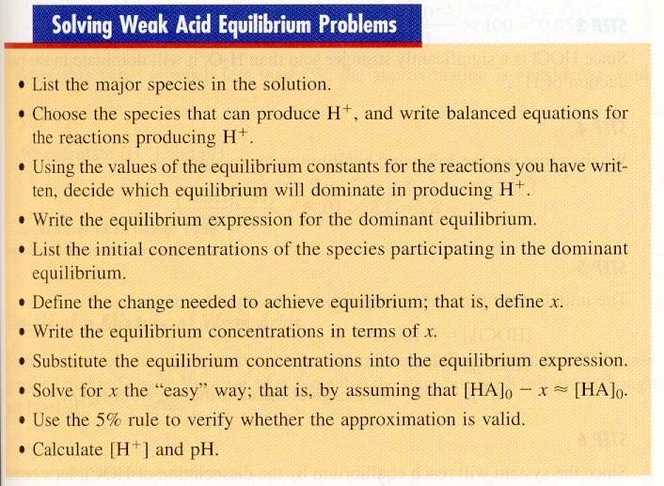

Exercise 10 The pH of Weak Acids

The hypochlorite ion (OCl−) is a strong oxidizing agent often found in household bleaches and
disinfectants. It is also the active ingredient that forms when swimming pool water is treated with chlorine. In addition to its oxidizing abilities, the hypochlorite ion has a relatively high affinity for protons (it is a much stronger base than Cl-, for example) and forms the weakly acidic hypochlorous acid
(HOCl, Ka = 3.5 × 10-8). Calculate the pH of a 0.100 M aqueous solution of hypochlorous acid.

pH = 4.23
Determination of the pH of a Mixture of Weak Acids

Only the acid with the largest Ka value will contribute an appreciable [H+]. Determine the pH based on this acid and ignore any others.

Exercise 11 The pH of Weak Acid Mixtures

Calculate the pH of a solution that contains 1.00 M HCN (Ka = 6.2 × 10−10) and 5.00 M HNO2
(Ka = 4.0 × 10−4). Also calculate the concentration of cyanide ion (CN−) in this solution at equilibrium.

pH = 1.35 [CN−] = 1.4 × 10−8 M

Exercise 12 Calculating Percent Dissociation

Calculate the percent dissociation of acetic acid (Ka = 1.8 × 10−5) in each of the following solutions.

a. 1.00 M HC2H3O2

b. 0.100 M HC2H3O2

A: = 0.42 % B: = 1.3 %
Exercise 13 Calculating Ka from Percent Dissociation

Lactic acid (HC3H5O3) is a waste product that accumulates in muscle tissue during exertion, leading to pain and a feeling of fatigue. In a 0.100 M aqueous solution, lactic acid is 3.7% dissociated. Calculate the
value of Ka for this acid.

Ka= 1.4 × 10−4

Determination of the pH of a weak base is very similar to the determination of the pH of a weak acid.
Follow the same steps. Remember, however, that x is the [OH−] and taking the negative log of x will give you the pOH and not the pH!

Exercise 14 The pH of Weak Bases I

Calculate the pH for a 15.0 M solution of NH3 (Kb = 1.8 × 10−5).

pH = 12.20

Exercise 15 The pH of Weak Bases II
Calculate the pH of a 1.0 M solution of methylamine (Kb = 4.38 × 10−4).

pH = 12.32

Calculating pH of polyprotic acids

Acids with more than one ionizable hydrogen will ionize in steps. Each dissociation has its own
Ka value.
The first dissociation will be the greatest and subsequent dissociations will have much smaller equilibrium constants. As each H+ is removed, the remaining acid gets weaker and therefore has a smaller Ka. As the negative charge on the acid increases it becomes more difficult to remove the positively charged proton.

Looking at the Ka values, it is obvious that only the first dissociation will be important in determining the pH of the solution.

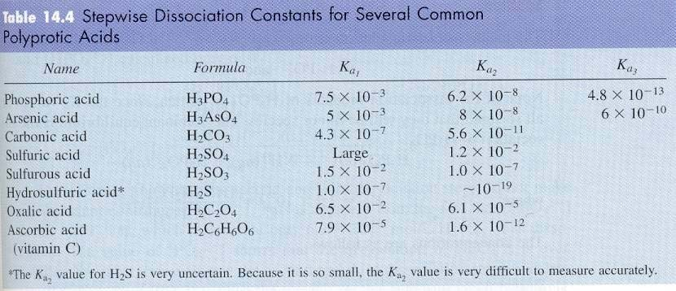

Except for H2SO4, polyprotic acids have Ka2 and Ka3 values so much weaker than their Ka1 value that the 2nd and 3rd (if applicable) dissociation can be ignored. Except for H2SO4, determining the [H+] or pH of polyprotic acids is beyond the scope of the AP exam. Because H2SO4 is a strong acid in its first dissociation and a weak acid in its second, we need to consider both if the concentration is more dilute than 1.0 M. The quadratic equation is needed to work this type of problem.

Exercise 16 The pH of a Sulfuric Acid

Calculate the pH of a 1.0 M H2SO4 solution.

pH = 0.00

Exercise 17 The pH of a Sulfuric Acid

Calculate the pH of a 1.0 × 10−2 M H2SO4 solution.

pH = 1.84

ACID-BASE PROPERTIES OF SALTS: HYDROLYSIS (Splitting of water)
Salts are produced when an acid and base react. Salts are not always neutral. Some hydrolyze with water to produce aqueous solutions with pHs other than 7.00.

Neutral Salts--Salts that are formed from the cation of a strong base reacting with the anion of a strong acid are neutral. Beware of solubility issues! One salt such is NaNO3. Think about which acid reacted with which base to form the salt…if both the acid and base are strong, then the salt is neutral.

Basic Salts--Salts that are formed from the cation of a strong base reacting with the anion of a weak acid are basic. Again, beware of solubility issues! The anion hydrolyzes the water molecule to produce hydroxide ions and thus a basic solution. K2C2H3O2 should be basic since C2H3O2− is the CB of the weak acid HC2H3O2, while K+ does not hydrolyze appreciably.
C2H3O2− + H2O ↔ OH− + HC2H3O2
strong base weak acid

Acidic Salts- Salts that are formed from the cation of a weak base reacting with the anion of a strong acid are acidic. The cation hydrolyzes the water molecule to produce hydronium ions and thus an acidic solution. NH4Cl should be weakly acidic, since NH4+ hydrolyzes to give an acidic solution, while Cl− does not hydrolyze.
NH4+ + H2O ↔ H3O+ + NH3
strong acid weak base

If both the cation and the anion contribute to the pH
situation, compare Ka to Kb.
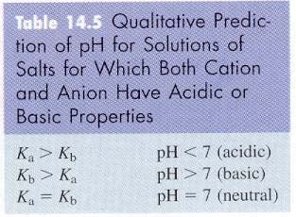 If Kb is larger, basic! The converse is also true.

Exercise 18 The Acid-Base Properties of Salts

Predict whether an aqueous solution of each of the following salts will be acidic, basic, or neutral. Prove with appropriate equations.

a. NaC2H3O2

b. NH4NO3

Exercise 19 Salts as Weak Bases

Calculate the pH of a 0.30 M NaF solution. The Ka value for HF is 7.2 × 10−4.

pH = 8.31

Exercise 20 Salts as Weak Acids I

Calculate the pH of a 0.10 M NH4Cl solution. The Kb value for NH3 is 1.8 × 10−5.

pH = 5.13

Exercise 21 Salts as Weak Acids II

Calculate the pH of a 0.010 M AlCl3 solution. The Ka value for Al(H2O)63+ is 1.4 × 10−5.

pH = 3.43

