Name _________________________________ Class___________ Date ____________________

PHYSICS REVIEW 5.3, 3.1, 3.2
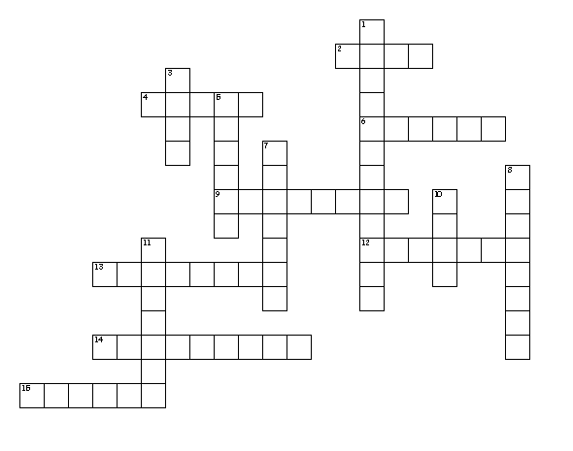
Across
2. HEAVIER OBJECTS HAVE _____ FRICTION.
4. UNIT OF ENERGY AND WORK.
6. THE ABILITY TO CAUSE A CHANGE TO AN OBJECT.
9. FOR EVERY ACTION FORCE THERE IS A REACTION FORCE.
12. FORCE MULTIPLIED BY TIME.
13. FORCE THAT RESIST THE MOTION OF OBJECTS.
14. ENERGY DUE TO THE POSITION OF AN OBJECT.
15. TYPE OF FRICTION BETWEEN OBJECTS THAT ARE NOT MOVING.
Down
1. _____ OF ENERGY STATES THAT ENERGY CANNOT BE CREATED OR DESTROYED.
3. WHEN A FORCE MOVES AN OBJECT THRU A DISTANCE ____ IS DONE.
5. DETERMINES THE TIME FOR A PENDULUM TO MAKE ONE COMPLETE SWING.
7. THIS TYPE OF FRICTION IS ALWAYS LESS THAN STATIC FRICTION.
8. MASS OF AN OBJECT MULTIPLIED BY ITS VELOCITY.
10. IF THE SPEED OF AN OBJECT IS DOUBLED THE KE INCREASES BY _____ TIMES.
11. ENERGY OF MOTION.

Complete the following problems showing all 5 steps. The equations listed below will also be given on the test so practice using them. Don’t forget the UNITS!
P = mv F t= mΔv W = Fd PE = mgh KE = ½ mv²
- Which has more momentum: a 5000-kg truck moving at 10 m/s or a sports car with a mass of 1200-kg moving at 50 m/s?

- A1. 2-kg shot put is accelerated from rest to a speed of 6.5 m/s. A constant force of 30-Newtons is used to change the momentum. For how much time does the force act?

- A 5-kg can of paint is sitting on top of a 2-meter high step ladder. A) what is the potential energy of the can of paint? B) how much work was done to place it on the ladder?

- How much work is done to move a car with 8500-N of force a distance of 20 meters?

- Alexis is riding her skateboard. If Alexis has a mass of 50-kg, what is her kinetic energy is she travels at 6 m/s?

Use the coaster diagram to answer questions 6 & 7:
- Where does the coaster have the greatest PE?
- Where does the coaster have the greatest KE?
- How did the coaster get its potential energy?
- The coaster will slow down as it travels through the track. Explain what slows the train? What happens to the energy?

