C:\Documents and Settings\mcmichael\Local Settings\Temporary Internet Files\Content.IE5\6XQNTD1B\MCNA00075_0000[1].wmfName\_\_\_\_\_\_\_\_\_\_\_\_\_\_\_\_\_\_\_\_\_\_\_\_\_\_\_\_\_\_\_\_\_\_\_\_\_\_\_\_\_\_\_\_\_\_\_ Period\_\_\_\_\_\_

**Reading Guide Section 20.1 (pages 434-440)**

1. Define the term “wave”.
2. What do waves transport from one place to another?
3. List five properties of all waves.
4. List the two types of waves and give an example of each type.
5. What are the units used to measure frequency?
6. Label the diagram with the following terms: crest, trough, wavelength, amplitude

**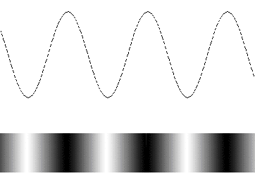**

1. What two things do you multiply together to calculate the speed of a wave?
2. How does a microwave heat food?
3. Higher \_\_\_\_\_\_\_\_\_\_\_\_\_\_\_\_\_\_\_\_\_\_\_\_\_\_\_ waves have shorter wavelengths.